**ABES ENGINEERING COLLEGE, GHAZIABAD(UP)**

**COA(KCS-302): Question Bank**

**Unit-1**

1. Define the term Computer Architecture and Computer Organization? **(2020-21 Odd Sem)**
2. What is mean of bus arbitration and list the types of bus arbitration? **(2020-21 Odd Sem)**
3. 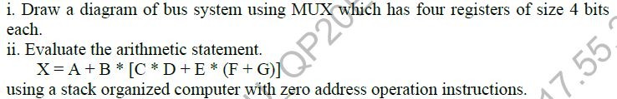

**(2020-21 Odd Sem)**

1. 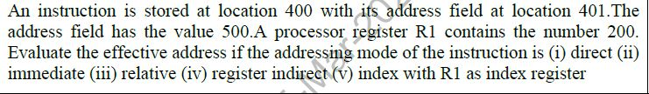

**(2020-21 Odd Sem)**

1. What do you mean by Processor Organization? Explain various types of processor organization. **(2020-21 Odd Sem, 2019-20, 2017-18)**
2. Draw the basic functional units of a computer. **(2019-20 Odd Sem)**
3. 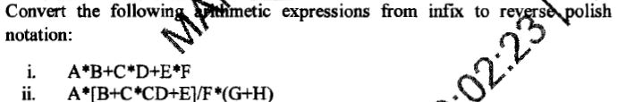

**(2019-20 Odd Sem) 2019-20**

1. Describe in detail the different kinds of addressing modes with an example. **(2019-20 Odd Sem)**
2. Discuss the stack organization? Explain the following in details **(2019-20 Odd Sem)**
3. Register Stack
4. Memory Stack
5. Define the role of MIMD in computer architecture? (2019-20, 2018-19)
6. Explain the bus architecture with its types? Also discuss the IO bus architecture with block diagram.
7. Evaluate the given arithmetic statement X=(A+B)*(C+D) using general register organization, single accumulator and stack organization.(2018-19)
8. Classify the various registers in computer organization. (2017-18)

**Unit-2**

1. Discuss biasing with reference to floating point representation.
2. What is restoring method in division algorithm?
3. Explain in detail the principle of carry looks ahead adder and design 4-bit CLA adder
4. Show the systemic multiplication process of (20) X (-19) using Booth’s algorithm
5. Explain IEEE standard for floating point representation. Represent the number (- 1460.125)10 in single precision and double precision format.
6. Text

   Description automatically generated
7. 
8. Explain IEEE standard for floating point representation with example.
9. Represent (−456.1234)10 in single precision and double precision format.
10. Show the systematic multiplication process of (20) × (−19)using Booth’s Algorithm
11. 
12. Perform the following operation on signed numbers using 2’s compliment method: (56)10 + (-27)10
13. 
14. 
15. 

**Unit-3**

1. Define micro-operation and micro code.
2. What is the difference between RISC and CISC?
3. Draw the flowchart for instruction cycle with neat diagram and explain.
4. What is a microprogram sequencer? With block diagram, explain the working of micro program sequencer.
5. Differentiate between hardwired and micro programmed control unit. Explain each component of hardwired control unit organization.
6. Draw the timing diagram for an instruction cycle and explain.
7. Give a note on subroutine.
8. What is parallelism and pipelining in computer architecture?
9. Explain the organization of microprogrammed control unit in detail.
10. Define horizontal and vertical microprogramming
11. Register A holds the 8-bit binary 11111111. Determine the B operand and the   
     logic micro-operation to be performed in order to change the value in A to
12. 01101111
13. 11111100
14. Differentiate between Synchronous and Asynchronous communication taking suitable example
15. List three types of control signals.
16. How pipeline performance can be measured? Discuss a space time diagram for visualizing the pipeline behavior for a 4-stage pipeline.
17. Write speed up performance laws.
18. Describe instructions formats
19. Memory Reference instruction formats
20. Register Reference Instruction Formats
21. Input-Output Reference Instruction Formats
22. Explain program control with neat and clean diagram.